A Christmas Message from the Frisingers, Dec. 2011

Greetings friends and family,

Ava grabbed all the headlines this year. Her cataracts were getting so bad I was having to do some of the night driving on trips so obviously surgery was called for. The surgery on the first eye went great so naturally she was anxious to get the second eye taken care of. The surgery on the second eye did not go as well. The initial surgery had complications that left particles floating in the eye. The fix for that was a much more complicated procedure so Ava was referred to a special specialist. That surgery took care of the original problem so the next day we headed off to Spokane to visit friends and for Ava to attend a conference. Unfortunately her eye sight went haywire again. She went to see the eye specialist at the local branch of our health care provider and found out that the pressure in the eye was about zero. The eyeball is basically a balloon and without pressure it loses its roundness. Needless to say the optics do not deal with this problem well. We rushed back home so Ava could see the doctor that did the surgery the next day. Her luck had finally turned, the problem cleared up on its own. I have a picture of Ava just after she came out of surgery with a big metal patch over her eye but as Ava has problems looking the way she sees herself in the best of times, I will spare all how she looks in the worst of times.

You might think this is enough medical trauma for anyone in a year but Ava is so tough she didn’t stop there. She dislocated her right shoulder while on the job. Rob had an on the job injury like that once but then he is a framer. Needless to say everyone asked how she did it. It turns out she was pushing a fire engine at the time.

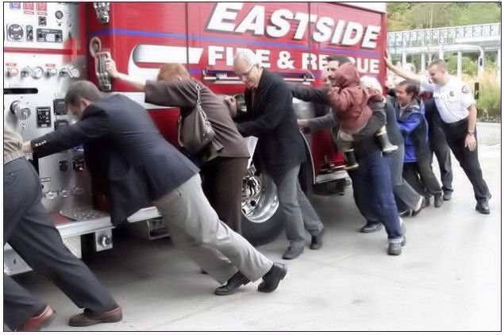
As most people do not find this a plausible answer Ava has invented a number of others like I was beating her up, so to eliminate any confusion I have included a picture of her pushing the fire engine and another one of her presenting the city budget to the council that evening. She is even wearing the same outfit.
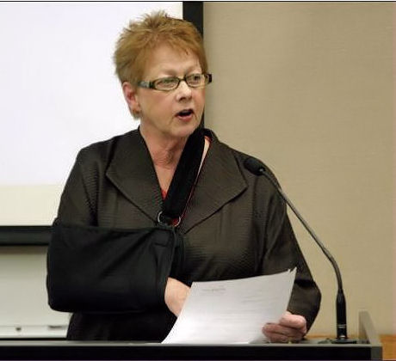
In a more indirect way, injuries have also affected me. My hiking buddy Dave Gimmestad tore two holes in his stomach while cross country skiing with me. He managed to do this without falling or hitting anything. It took a few days to figure out the full extent of the damage but when they did they rushed him in to surgery, not even waiting until morning. I did not realize there was any emergency bad enough to get a doctor out of bed. As a result of this our weekly outings have continued at a slower pace. It is nice to be in the lead sometimes so there are advantages.

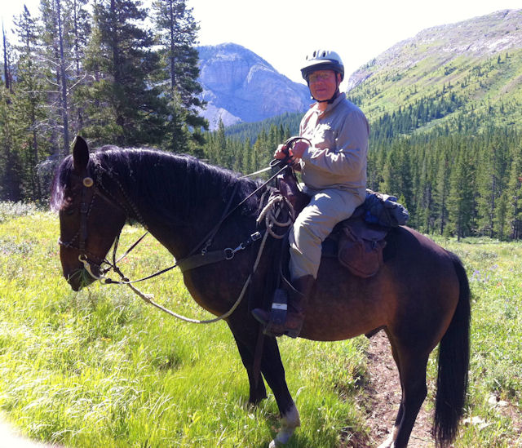
My interesting adventure of the year was to go on a ten day back trip in the John Marshall wilderness in Montana. It was a great experience. There were nine guests and a crew of four. We moved camp every few days. I did elect to stay in camp one day and let my body heal and to permit a leisurely sponge bath. The weather was good with only a few light sprinkles a couple of nights. It did get cold a few nights in spite of it being August. We had frost three nights and one guest had a thermometer that indicated it was in the upper twenties in the tent one night. I was using the sleeping bag left over from my snow camping days so I was fine.

The grandkids are all doing fine. We had a scare that my granddaughter Ava who is in the first grade had a reading problem. I was a little offended, at worst, she was as smart as me so I did not see the problem. But you know how parents are. It turned out she was just bored with reading and felt it was a lot more fun and less work to have someone else read to you.

Our twenty year old granddaughter Kaleigh is now working part time for a world renowned glass artist named Martin Blank. The first day on the job he asked her how she was with power tools. She explained that the previous day she was working as a second man on a house framing crew working in the snow. He put her to work building a shipping container for his latest piece of art which was being shipped to Saint Petersburg Russia. One of the parts of the art piece weighed forty pounds.

Our favorite books for the year are as follows:
Ava: Cutting For Stone by Abraham Verghese
Bill: Girl with the Dragon Tattoo trilogy by Stieg Larsson (Film opens 12/21/11)
Diane: The Mayfair Witch series by Ann Rice.
Rob: Medicus : A Novel of the Roman Empire by Ruth Downie
Amber: The Other Boleyn Girl by Philippa Gregory
Kaleigh: The Circle Trilogy by Ted Dekker
Joshua (almost 15) Song of Ice and Fire by George R R Martin
Little Ava (almost 7): Scooby-Doo and the Legend of the Vampire by Jesse Leon McCann
Ameerah/Lilianna (18 months) That's Not My Tractor by Fiona Watt (A touchy feely book in the spirit of Pat the Bunny).

May the New Year be a bright new start for us all.
Yours,

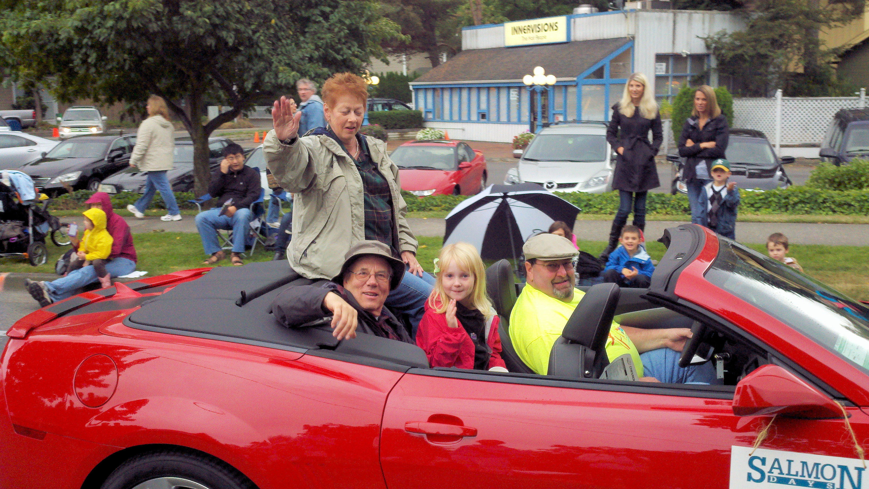
Ava, me and Little Ava in the lead car in the Issaquah Salmon Days parade

bill@frisinger.net, http://www.frisinger.net

