A Christmas Message from the Frisingers, Dec. 2010

Greetings friends and family,

The big news this year is Rob and Amber had twin girls born July 27th. Ameerah Rose popped out first weighing in at 5 Lbs 8 Ozs followed by Lilianna Clara 4 minutes later weighing 4 Lbs, 11 Ozs.
Ameerah, Amber and Lillianna

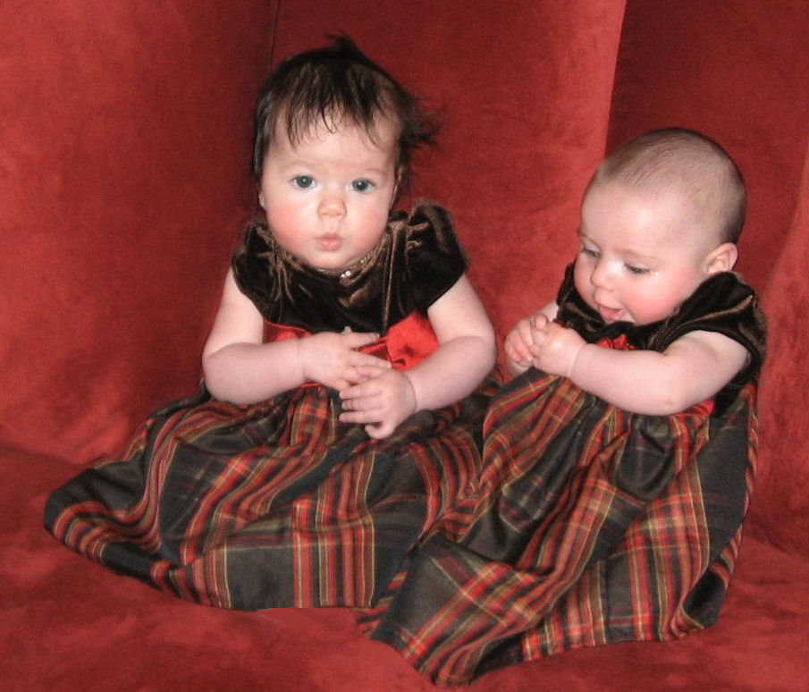
Ameerah and Lillianna

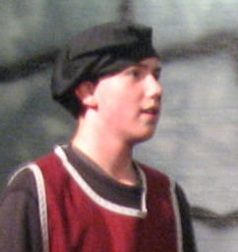

Ava accompanied me to my 50th high school reunion in Ann Arbor. Then we Joined Ava’s cousins Jeannie and Lisie at a cottage we had rented on Big Glen Lake west of Traverse City Michigan. This is the second year we have done this and it is working out well. The high point for me was a canoe trip on the upper Platte River with Gordy. It felt really good to
be pulling hard on the paddle seeing the water part at the bow of the canoe. Of course my back hurt for weeks afterwards, but that was a small price to pay.
Gordy, Ava and Jeannie at Big Glen Lake.
Lisie, Terry and I were in hiding.

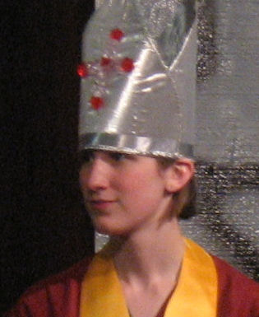
Joshua and Kaleigh were both in a production of Shakespeare’s Richard the Third.

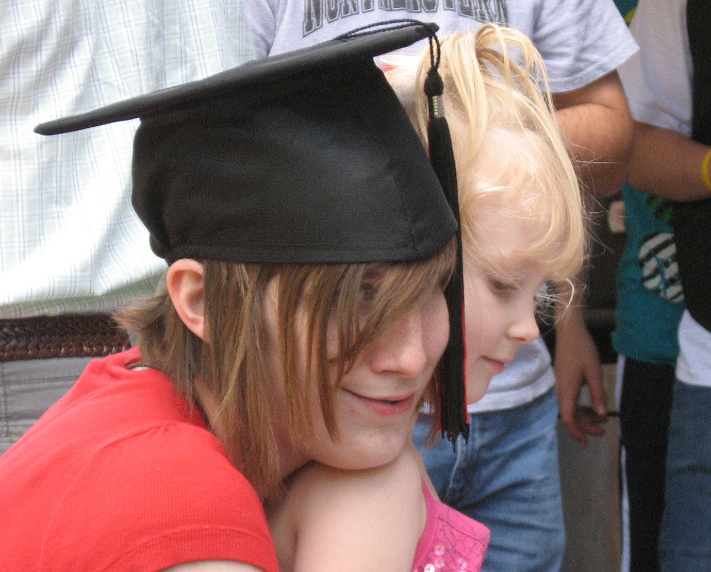
This year saw Kaleigh graduating from high school and little Ava graduating from pre-school. Both are continuing their education:
Kaleigh at Pratt Fine Arts Center in Seattle and Ava at Opstad Elementary in North Bend.
Ava is staying busy as mayor. She is very dedicated. For our 45th wedding anniversary she is chairing the city council meeting to adopt the budget. She does manage to get other family members involved occasionally. Little Ava accompanied Mayor Ava to a breakfast with the mayor(A event where the following picture was taken.
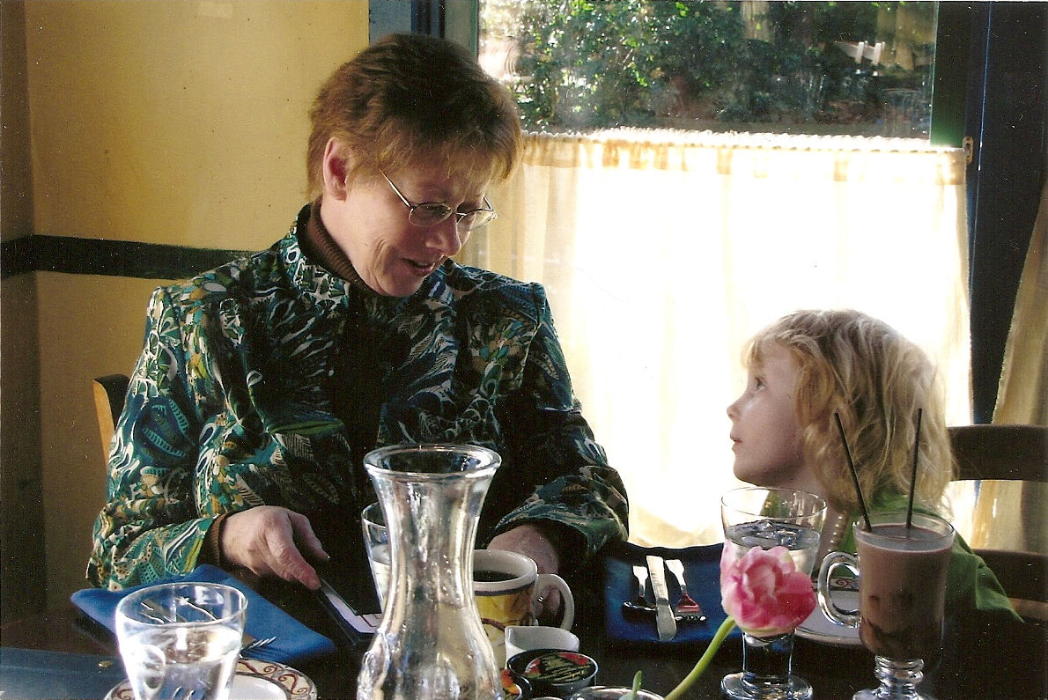

I have started getting Kaleigh and Joshua out on snow hikes.
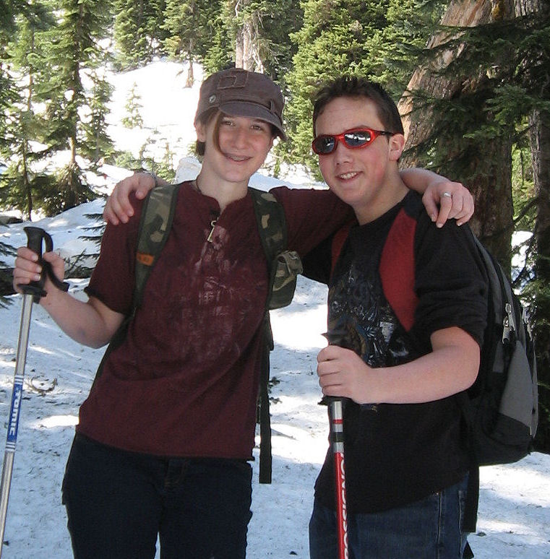
This is on a spring hike to Source Lake in the Snoqualmie Pass area.

Joshua's (age 14) favorite book is Attila by William Napier and Genghis: Birth of an Empire by Conn Iggulden. Kaleigh’s (age 19) favorite book is Advanced Glass working Techniques by Edward T. Schmid.
Ameerah and Lillianna (age 5 months) are getting in to books early. Their favorite is Stranger in the Woods by Carl R Sams and Jean Stoick.

Amber, Rob and I like Ken Follett’s new book, Fall of Giants, it is the first part of the Century Trilogy. It is very good about giving the reader a complete picture of the world situation leading up to and through World War I.

Ava’s is An Altar in the World, a Geography of Faith by Barbara Brown Taylor.
Diane’s is The Bhagavad Gita translated by Eknath Easwaran. Little Ava’s (age 6) favorite book is The Rainbow Tiger by Gayle Nordholm illustrated by Jennifer Frohwerk.
May the New Year be a bright new start for us all.
Yours,


bill@frisinger.net

Me taking a break in the warming hut at Grand Junction above Snoqualmie Pass.
I am starting to look like an old man. There are days when I feel like one too.

