A Christmas Message from the Frisingers, Dec. 2009
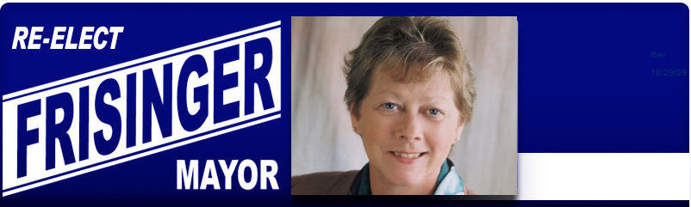
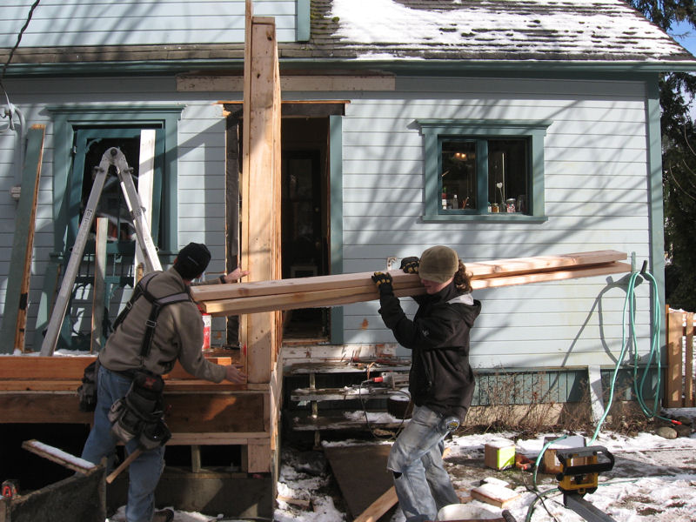

Greetings friends and family,

The big news this year is Ava won her election to a fourth term as mayor. You might say, “big deal, she had no opposition” but the story is we worked very hard to see to it that she had no opposition. For example we know what consultant the most likely opponent would use. We hired the consultant first.

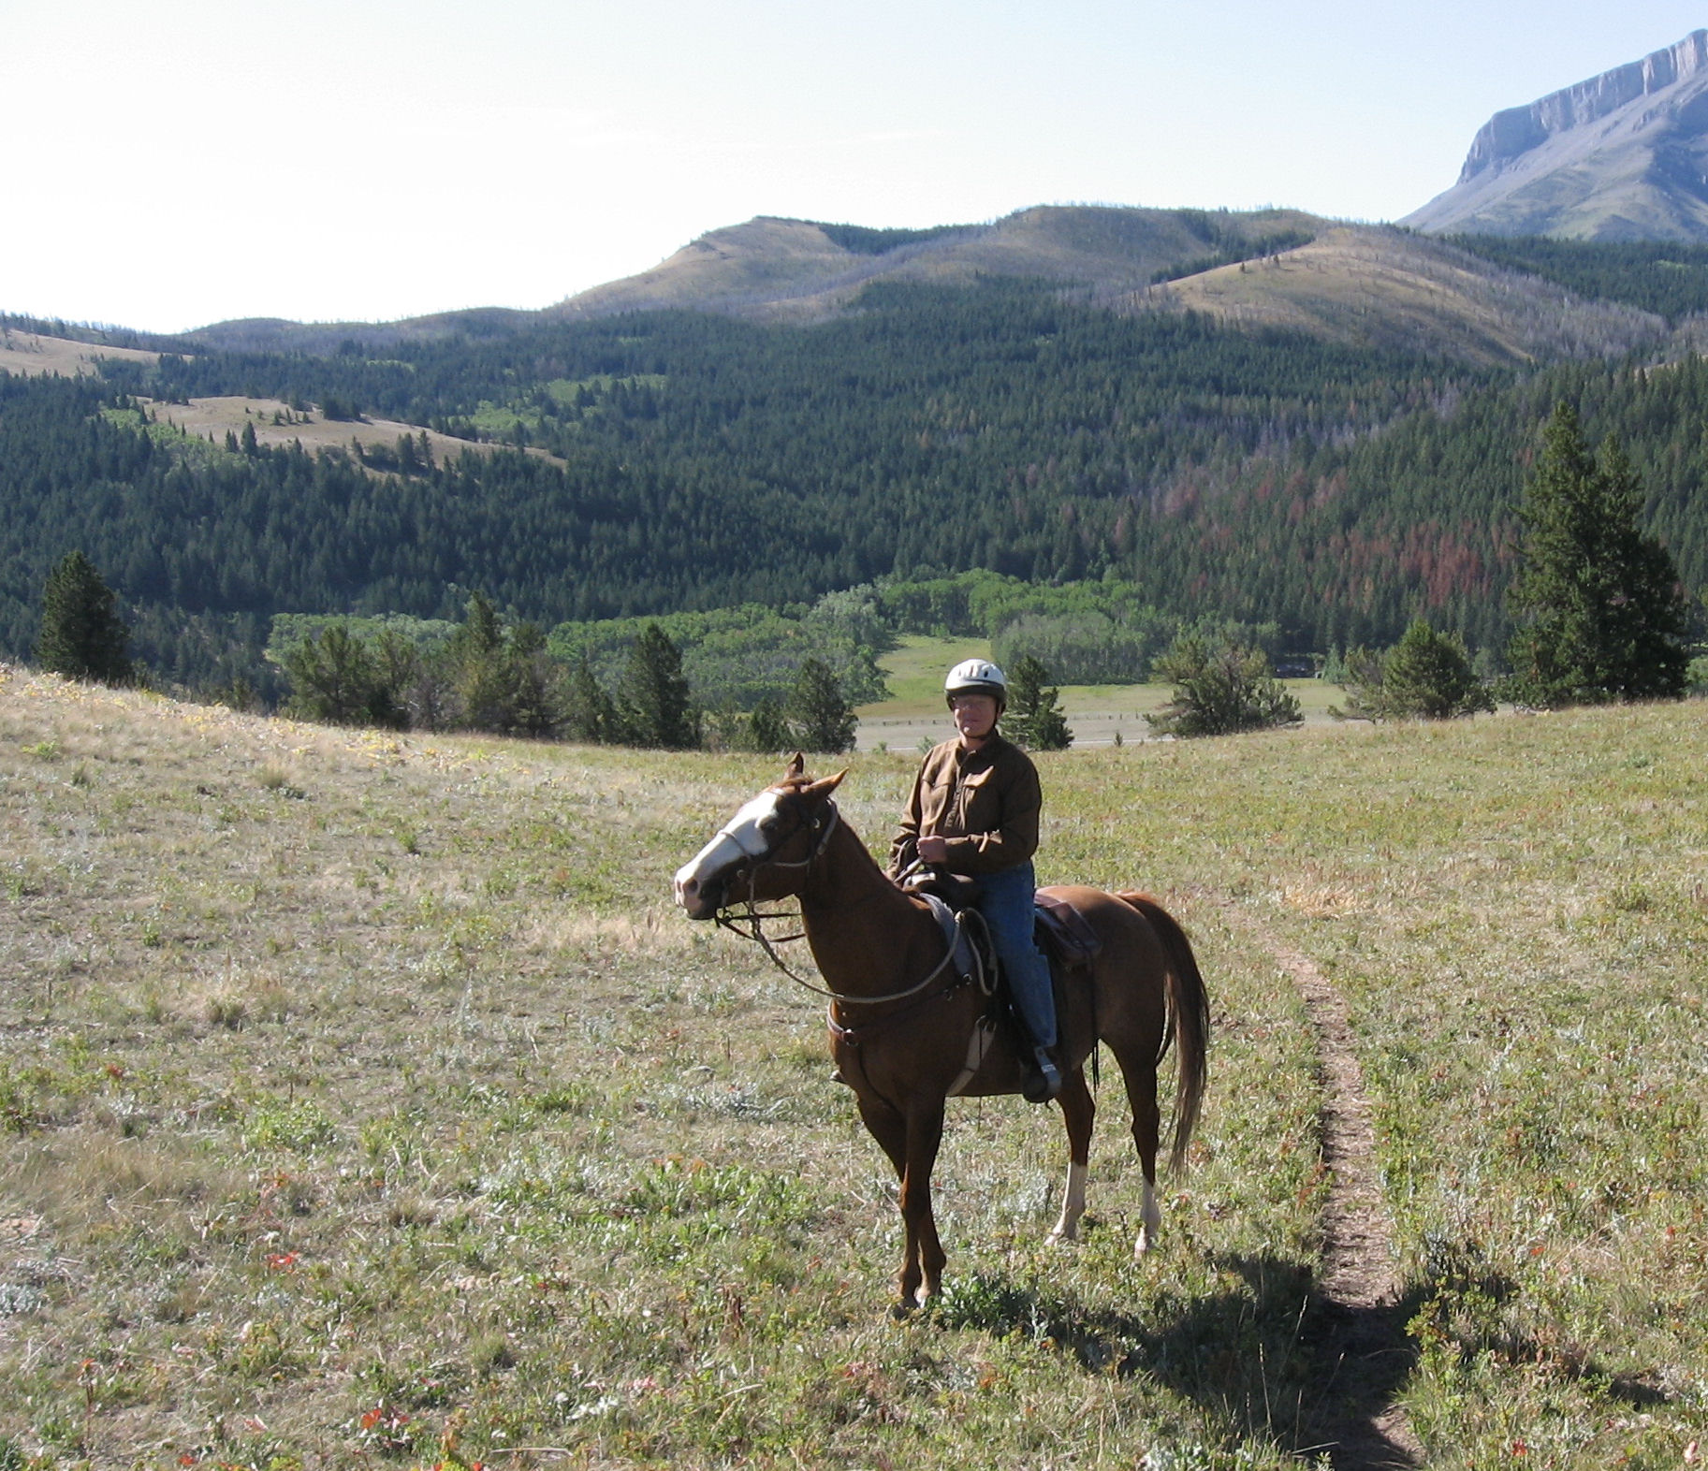

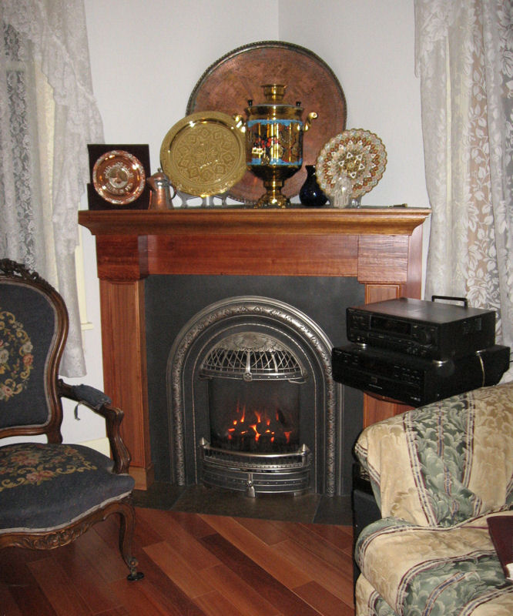
The biggest news for me is the trip he did to a dude ranch in Montana, the 7 Lazy P. It is on the edge of the Bob Marshall Wilderness on the edge of the Rockies. http://www.sevenlazyp.com

My weekly hikes with Dave Gimmestad continue. I try to upload a couple of pictures from each hike to my facebook page.

We also did a major remodel this last summer. Rob needed work and we needed a remodel so we put two and two together. We now have a completely remodeled and expanded kitchen, added a back mud room, a gas fire place and hard wood floors throughout the first floor. The down side to having a family member do the work, is that other jobs are always more important. In fact Rob was working on some final stuff fixing our front porch today.

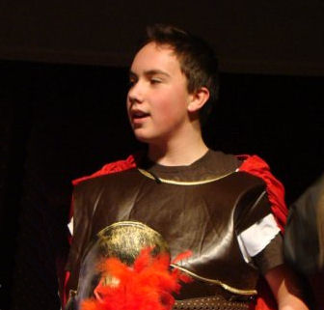
Rob and Amber's kids are doing well. Joshua, soon to be a teenager, has developed a great interest in Greek history. It started with the young adult book series, and progressed to all the Greek text books Rob had used in college. He then moved on to books Rob’s college professor sent and now he is watching DVDs put out by the Teaching Company. He is also involved in drama playing a number of parts in a play about a possible fourth wise man.

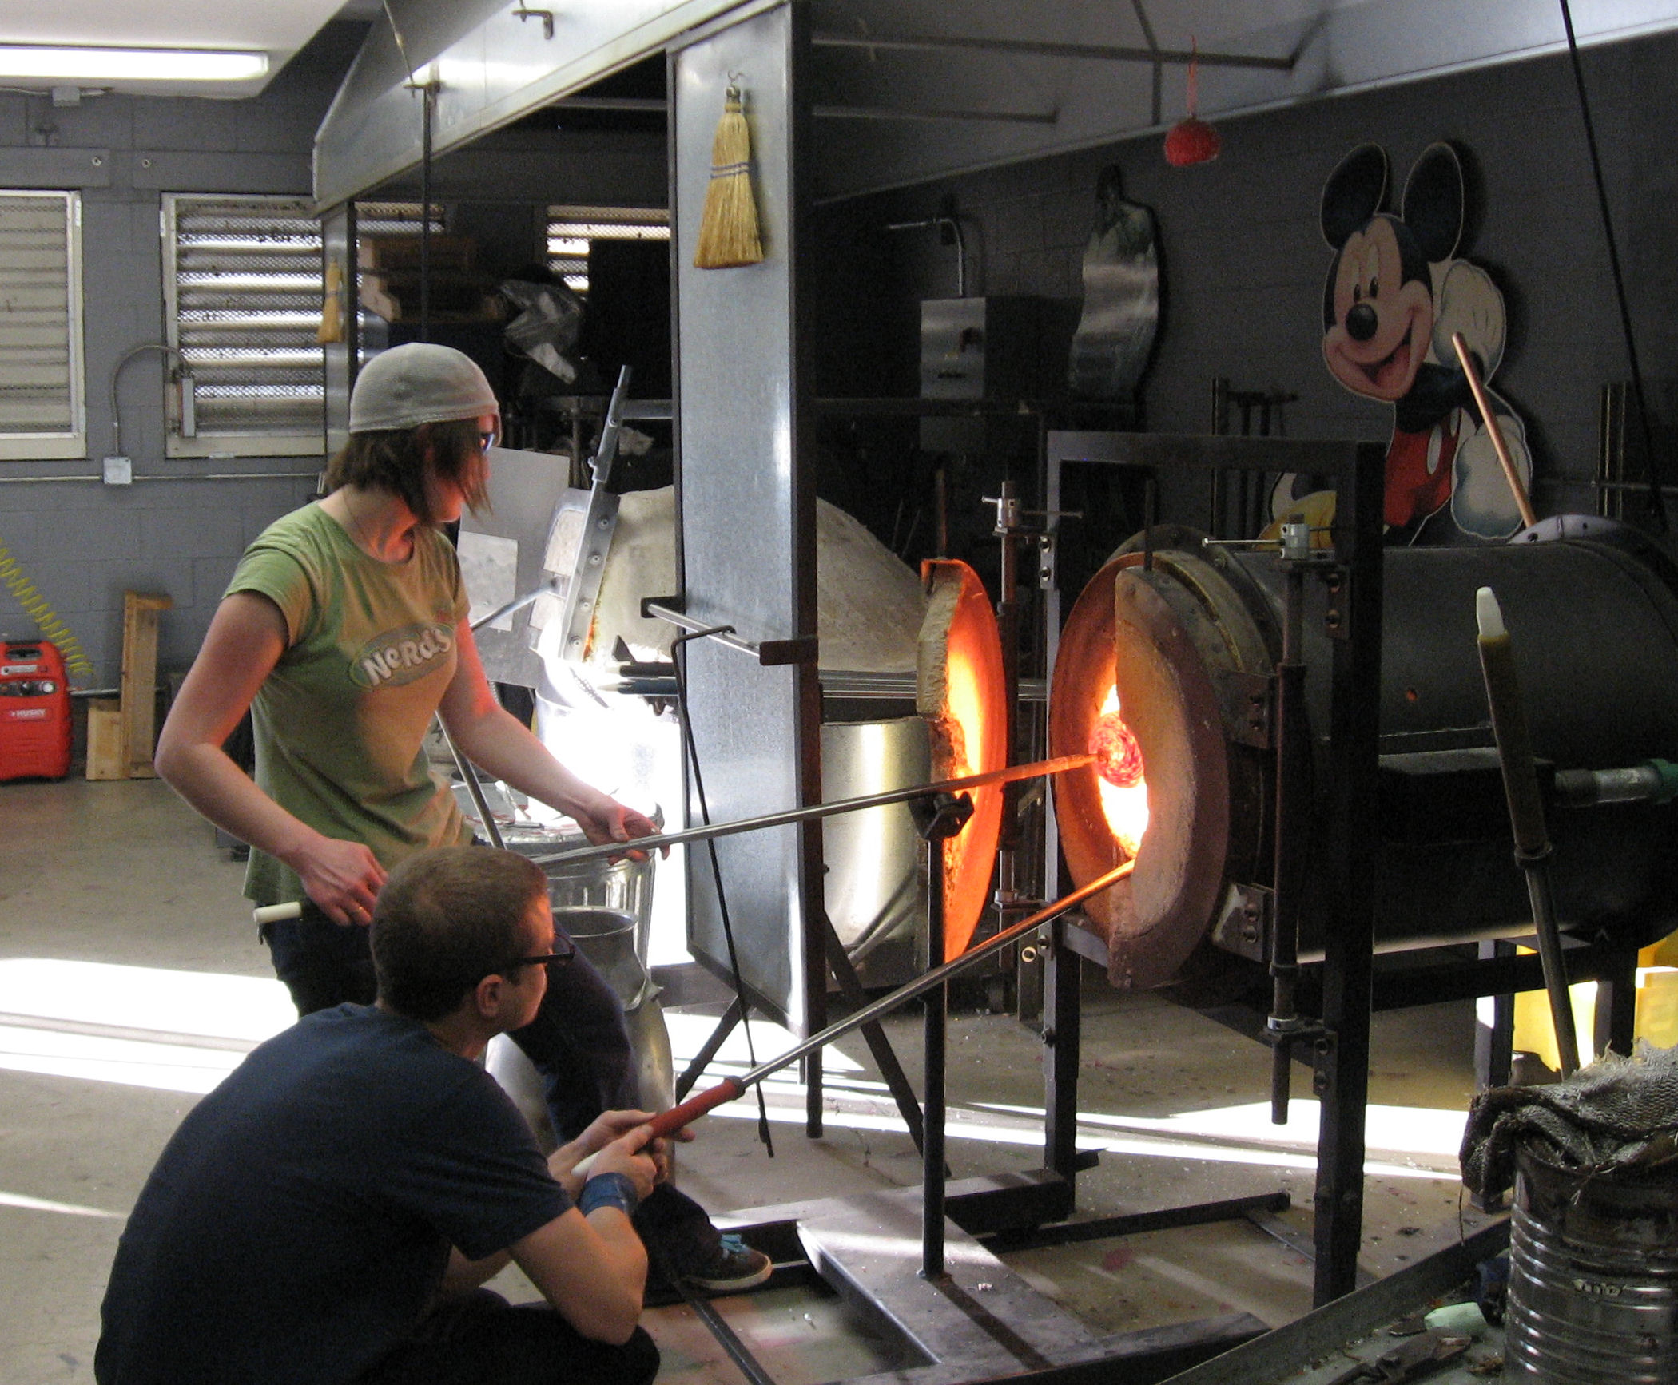
Kaleigh’s interest in glass art continues. She works part time as an assistant at the glass studio in Issaquah. She has not been working as much for her dad this year because the construction industry is in the dumps here like most everywhere else. Business is looking up a little this fall but the best that is likely is a slow recovery in housing starts.
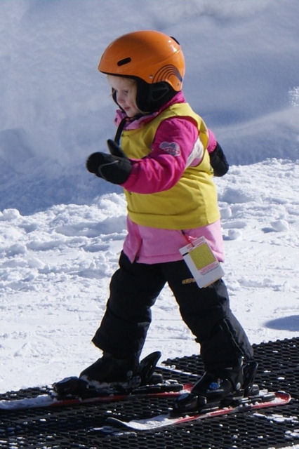
This year when Scott, Diane and Ava came up to our condo to snowmobile, they got a shock. Ava had no interest in snowmobiles, they were too noisy but skiing was great. I have been kidding them for years that I would make a skier out of her.
Joshua's (age 13) favorite book was the Percy Jackson series (The Battle For The Labyrinth is the best) by Rick Riordan. This series features the adventures of a typical high school kid except he is a Greek god. This is what got Joshua interested in Greek history. Kaleigh’s (age 18) favorite is the Circle Triage by Ted Decker. Little Ava’s (age 5) favorite book is the non-fiction book Magic Tree House Research Guide, Mummies and Pyramids by Will Osborne and Mary Pope Osborne.

Amber and Rob liked Wesley the Owl: The Remarkable Love Story of an Owl and His Girl by Stacey O'Brien. Mine is Winter Study by Nevada Barr. Ava’s is In an Instant by Bob and Lee Woodruff.

Diane is just one shy of re-reading all 12 if the Ann Rice vampire books since May. They are definitely her favorite in fact she is trying to get first hardcover edition of all of them.
May the New Year be a bright new start for us all.
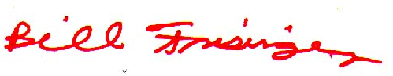
Yours,

http://www.frisinger.net

